S A DRAGONS ABREAST INC.
(SADA)

www.sadragonsabreast.com.au

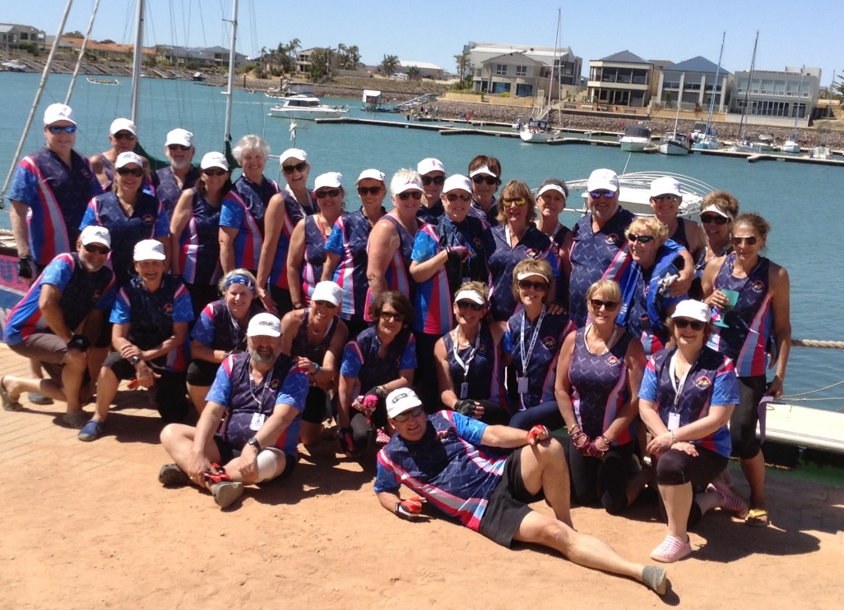

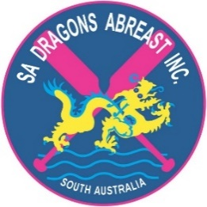

CLUB MANUAL

2

WELCOME TO SA DRAGONS ABREAST (SADA)

Welcome to all paddlers joining us for the first time or returning after a break.
Dragon boat racing is a unique, exciting and fun team sport. We encourage and assist newer members to determine the level at which they wish to participate and enjoy the sport for its healthy lifestyle, social and competitive benefits.
A crew consists of 22 participants including 20 paddlers, one sweep who steers the boat and a drummer who beats the rhythm of the paddling stroke. Races are held in Open, Mixed, Women’s, and Breast Cancer Challenge events over 200m, 500m, 1k, and 2km and the ‘Peter Bristow Long Course’ over 7 km.

HISTORY
In 1996 the first Dragons Abreast team was formed in Canada organised by Dr Don McKenzie, a sports medicine and exercise physician. He set about proving that people who have been treated for breast cancer can participate in strenuous activities involving the upper body, therefore improving lymphatic drainage.

SA Dragons Abreast Inc. was established in December 2001 to support and provide hope and inspiration to survivors of breast cancer. The aim was to help raise awareness of the disease by providing the opportunity for survivors, their families and supporters to participate in the sport of dragon boat racing.

SADA is a member group of Breast Cancer Network Australia (BCNA), the International Breast Cancer Paddler’s Commission ((IBCPC), Australian Charities and Not-for-profits Commission (ACNC) and DragonBoat SA (DBSA).
Our founder was Carlene Butavicius, Board member of BCNA, who played a key role in the formation of the club.
Members have competed in international regattas in Rome, Cape Town, Penang, Hong Kong, Ravenna in Italy, Adelaide’s ‘Dragons Down Under’, Bali International Festival and at numerous local and national events.

We aim to
- Support and provide hope and inspiration to breast cancer survivors
- Raise awareness of breast cancer through participation in the sport
- Demonstrate that women and men living with breast cancer can lead full and active lives
- Provide a support network for survivors undergoing treatment or suffering ill health
- Promote wellness, fitness, fun, camaraderie and a sense of wellbeing for all members
- Develop our club spirit and unity by encouraging each member to become actively involved with the welfare and safety of all other members and the club as a whole.
3

TRAINING

Training duration is approximately one and a half hours and is held at Aquatic Reserve, Bower Road, West Lakes.
Paddlers should arrive 20-30 minutes before training time to assist with launching boats and for warm up exercises.

Saturday West Lakes - on water at 10am.
Tuesday West Lakes – on water at 6pm
Thursday West Lakes – on water at 6pm (as advised)

Training sessions are scheduled by the coach, the boat captains(s) and the Committee and a recess of training is at times called by them.

A Level 3-5 accredited sweep must be present in the boat at all times and a mobile phone carried in case of emergency. There must be sufficient members present when moving boats for prevention of accident or injury.

Members may not take a boat out for training without the knowledge of the Committee as all boats are booked through DBSA.

If paddlers are selected in a team for special events, they will be expected to attend regular training sessions.

SADA recognises that fitness is a yearlong commitment and it is each paddler’s responsibility to maintain their fitness. Warm up and cool down exercises are part of each training session.

Dragon boat racing is a strenuous sport so it is advisable to consult your doctor prior to participating.
In the case of any health concerns or injuries, please notify the coach, boat captain or sweep.
Medical clearance may be required before competing in State, National and Club Crew World Championships (CCWC).
TRAINING GEAR

For training wear a T-shirt preferably in the club colours of pink/navy and navy or black, shorts or leggings, bike or lifting gloves, a hat, sunscreen and water bottle and a spray jacket if weather is wet or cold.
Aqua/water shoes must be worn and a change of clothes and a towel may be useful.
Shower facilities are available at the boat shed.

4

TEAM SELECTION

Paddlers for race day crews will be selected by a group consisting of Boat Captain(s), Coach and sweeps. Factors taken into consideration include attendance at training, attitude, boat discipline, commitment to improving general fitness, paddling technique and weight distribution in the boat for balance and safety.
The club has a Team Selection Policy – www.sadragonsabreast.com.au .

RACE DAY
Uniform race tops are required and clothing as for training sessions, plus a chair, water bottle, refreshments and a sense of fun.
Set up time is approximately 8.15 am with the first race at approximately 9 a.m., finishing at approximately 4pm.
Club members are at times rostered to help with official duties e.g. start and finish line and clubs are allocated a task for the day e.g. boat storage at the start and end of the day. Members are advised of these details prior to the race day.

DBSA race rules and regulations and the current race program can be viewed on the their website www.dragonboatsa.com

CODE OF CONDUCT

Both DBSA and SADA have Codes of Conduct set down in their Constitutions. Breaches of these Codes may involve penalties including suspension or expulsion from dragon boating events, the Club or the Association. It becomes the duty of each Club member to ensure that no member acts in any way that may bring disrepute to the Club or the Association.
Members of SADA are promoting both their Club and its sponsors by becoming a sporting ambassador. A member may not act in any way that may bring discredit to either SADA or to our sponsors.
Only by agreement with the Committee may members speak on behalf of the club.

PRIVACY

The SADA Committee respects your right to privacy. Your personal details will be used for administration purposes only and unless you agree otherwise, will not be disclosed to other people except as required by law or in other circumstances where disclosure is reasonably required (e.g. in a medical emergency) By applying to become a member of SADA you agree to be bound by the constitution of SADA, a copy of which can be obtained from the secretary if required or the website www.sadragonsabreast.com.au

5

UNIFORM

SADA has a club uniform identified by the club colours and logo. The uniform is to be worn on race days, at public engagements or when the club travels as a team. The club uniforms can be ordered and purchased through the Uniform Coordinator.
Racing: club race top with navy or black shorts/leggings, white cap or visor.
A navy or pink vest or jacket and spray jacket (raspberry for women and navy for men) is worn for warmth.
Casual: club polo shirt, navy or pink sleeveless vest or long-sleeved jacket in navy or pink and navy or black pants
Formal: as advised
Life jackets: Members may lease a life jacket from the club.

FUNDRAISING
Fundraising helps us to achieve one of our aims which is to attend local, interstate or international regattas. If members wish to participate in these events they will be called upon to contribute to or arrange fundraising activities.
Any donations of money received at speaking engagements will be passed to the Committee for use by the club as a whole.

THE COMMITTEE
Committee meetings are scheduled each month. Members are welcome, but please advise the Secretary of intention to attend as the venue for meetings may change.
The committee consists of a President, Secretary, Treasurer and five general committee members.

CONCERNS and INFORMATION
For any club issues or concerns, please contact the President or Secretary. On -water or paddling questions or concerns are to be addressed to the Coach or Boat Captain(s). Agenda items for Committee meetings are welcome and must be in writing to secretary@sadragonsabreast.com.au with cc to the President.

MEMBERSHIP FEES
To participate at any level, Club and DBSA membership is compulsory and includes insurance cover. The club also offers a Social, Friends of SADA and an Associate Membership. Further information re fees is available from the Membership Liaison Officer, the Treasurer or the website www.sadragonsabreast.com.au

6

BOAT SAFETY AND CAPSIZE

AIMS: to ensure the safety of all paddlers, particularly following a dragon boat capsize.

SAFETY: Every paddler must take responsibility for their own safety by following all the safety rules.

SAFETY RULES:

Number Off

- Once the boat is loaded and ready to paddle the sweep will call “number off”
- The drummer starts as number 1, followed by the front left hand paddler (the stroke), and then right hand paddler and so on down the boat.
- Remember your paddling partner
- Your paddling partner is your buddy if capsize occurs – each making sure their buddy is safe.
- Lead strokes also buddy with the drummer
- Back paddlers also buddy with the sweep

CAPSIZE:

- Stay calm
- The boat will float, whether inverted or not
- Ensure your own safety first
- The sweep ensures that all are accounted for by requesting a head count, starting with the person on their right and going around the boat
- If you come up under the boat, swim to the side then surface and let your buddy know you are OK
- Look for your buddy
- If they are not visible immediately advise the sweep and paddlers around you and continue to search
- All paddlers move to the sides of the boat
- Spread yourselves evenly along both sides of the boat (to stop it rolling over)
- Do not swim under the boat, always swim around it
- Swimming the boat to shore only under instructions from sweep

7

Capsize on RACE DAYS:

- Follow all above rules but do not swim boat to the shore unless instructed by the rescue boat
- Sweep to communicate with rescue boat – advise status of the head count

NON RACE DAYS:

WHEN SECOND BOAT PRESENT
- Second boat is not a rescue boat
- Sweep of capsized boat to advise second boat of head count. If paddler missing second boat to raise the alarm.

WHEN ONLY CAPSIZED BOAT IS PRESENT
- Follow rules of capsize

SAFETY RULES:

An accredited sweep must be in the boat at all training sessions and a mobile phone is to be carried by sweep or boat captain at training.

LIFE JACKETS:
It is mandatory for any paddler who cannot swim 50 metres or at least remain afloat for 15 minutes to wear a life jacket. A sweep must also wear a life jacket.
It is an Adelaide City Council direction that life jackets be worn while competing on the Torrens. At West Lakes life jackets are worn when paddlers are on the water after sunset. This generally coincides with daylight saving.
ASTHMA:
Paddlers who suffer from asthma must take medication with them in the boat.
FIRST AID - all sweeps and coaches are required to hold a current Senior First Aid Certificate.
A DEFIBRILLATOR – is available immediately to the left of the Rolladoor at Aquatic Reserve case of cardiac emergency.

CONTACTS AND LINKS:

S.A. Dragons Abreast Inc. – www.sadragonsabreast.com.au Find us on Facebook
DragonBoat SA – www.dragonboatsa.com
Australian Dragon Boat Assoc. – www.ausdbf.com.au
International Dragon Boat Federation – www.idbf.org

8

SWEEP’S CALLS
To avoid confusion, the Australian Dragon Boat Federation has issued the following calls to be used in Australia.
Call | Action
Head Count | Number off starting with the drummer as No 1
Paddles Set | Paddles forward just out of the water ready to paddle forward
Go, Gun, or siren | Go
Let it run or easy oar | Paddles out of the water and let the boat glide
Paddles Out | Paddles come out of the water and let the boat glide
Paddles Flat | Press the blade of your paddle flat on the water to keep the boat from rocking
Paddles Back | Paddles in the backward position ready to paddle backwards
Dig it in or Jam stop | Stop the boat by holding the paddle blade vertically in the water
Stop the Boat | Stop the boat by holding the paddle blade vertically in the water
Are You Ready? | The first call from the Starter.  Drummer holds up both arms if the crew is not ready
Attention | Move paddle to the start position
Back 2,3,4 Rows | Only paddlers in the designated rows paddle under the sweep’s instructions. Other paddlers have paddles out
Draw Left or Right | Move the boat sideways usually to line up for a start. Sometimes only the front or rear paddlers will be asked to draw
Hold Water | Hold the paddle blade vertically deep in the water to keep the boat still
Hold the drift | Hold water with the paddle blade parallel to the boat to stop it from drifting sideways
Rest / Relax | Rest / Relax

